(CSCI 251) Activity Three and Exam Three Review

Student Name Matthew Boyea

***Instruction:*** *The students are encouraged to type the answer use WORD and submit the word file through blackboard. To learn how to type math notation in word, please watch video* [*https://www.youtube.com/watch?v=SRGaW3maK38*](https://www.youtube.com/watch?v=SRGaW3maK38)*. You may search other videos to learn how to do this faster.*

*However, if the student feels it takes too much time to type the answer, then the student can use handwriting to write down the answers on paper. The students then scan the paper into pdf or image file then upload the file to blackboard. In this case, any unclear handwriting may result 0 points to the problem.*

*Exam Three consists of two parts. Part One is online multiple choices/fill in blanks. The students should review the embedded homework problems to prepare Part One. This activity is Practice Problem Set for Exam Three Part Two review. The questions in real Exam Three may not be the same questions listed here. However, the testing concepts will be the same or similar.*

Problem One (6 points, 2 points each) Answer the questions

1. What is the maximum number of leaves an n-node binary tree could have? Draw a 5-node binary tree example to demonstrate your answer.

**D**

**E**

**B**

**C**

**A**

$$maxLeafCount=ceil\left(\frac{n}{2}\right)$$

1. What is the minimum number of leaves an n-node binary tree could have? Draw a 5-node binary tree example to demonstrate your answer.

**E**

**D**

**C**

**B**

**A**

$$minLeafCount=1$$

1. What is the maximum height an n-node binary tree could have? Draw a 5-node binary tree example to demonstrate your answer.

**A**

**B**

**C**

**D**

**E**

$$maxHeight=n-1$$

Problem Two (6 points) Write recursive version of search algorithm for binary search tree. The recursive version takes a tree node and key as argument. If the tree node is null, returns false; if the tree node’s data match the key, return this node; otherwise, recursively search the key in tree node’s left or right child depending on the whether the data in this tree node is less than or greater than the key. You must also provide a driver algorithm, which take a BST and key as argument.



Problem Three (8 points) Build a binary search tree by insert the following data as the given order: 35, 18, 23, 56, 45, 39, 12

**18**

**56**

39

45

**23**

**35**

**12**

Problem Four (15 points, 5 points each) In given binary search tree, perform the following operations and draw the result tree:

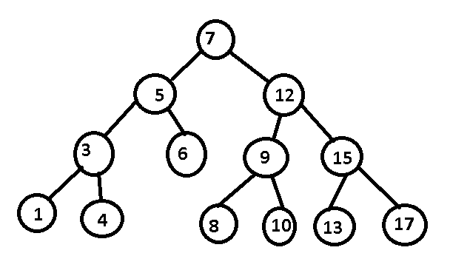

1. remove 12

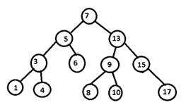

1. remove 6.

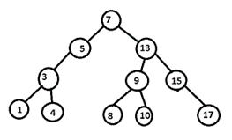

1. remove 5.

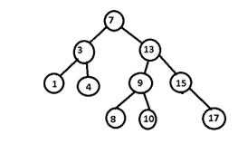

Problem Five (8 points) Write an algorithm that will print out the data in binary search tree from the largest to least.



Problem Six (10 points) Build an AVL tree by insert the following data as the given order: 35, 18, 23, 56, 45, 39, 12

**35**

**18**

**23**

39

**12**

**56**

45

Problem Seven (10 points) Self study heap sort by using Chapter Six Additional Materials or at <https://en.wikipedia.org/wiki/Heapsort>. Show the process to sort the following array in ascend order: 3, 1, 7, 5, 4, 6, 2. You may draw the heaps for each step.

Problem Eight (10 points) Use Dijkstra’s algorithm to find the shortest path from A to H.

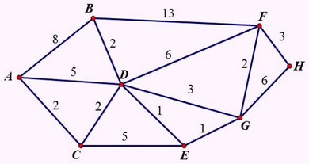

A C D E G F H

Problem Nine (10 points) Use Bellman-Ford algorithm to find the shortest path from s to each of other node in following graph

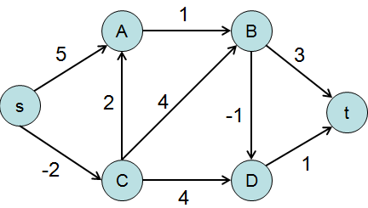

s->A: s C A

s->B: s C A B

s->C: s C

s->D: s C A B D

s->t: s C A B D t

Problem Ten (10 points) Draw a minimum spinning tree of the graph in Problem Eight.

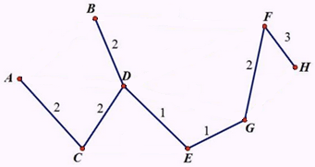

Problem Eleven (12 points, 4 points each question. Notice the total points in this assignment will be 105. However, the full credit is 100.) Review the AVL remove algorithm. Show the result trees one by one if you will remove:

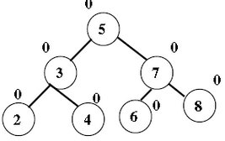

1. node 7

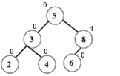

1. then node 4

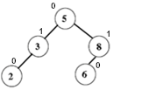

1. then node 5

